MGMS – Create Site Admin

Detailed Design Document

Ver. 1.4

Version History
Date | Description
27-Oct-2010 | First draft

Table of Contents

Version History 2
1 Introduction 4
2 Create Site Admin 4
3 Associated tables 6
4 Data Dictionary 6

Introduction

This document provides the detailed design specifications for the Multisite Grant Management System project.

This is not a project plan nor does it detail the source code. It is a guide for system architecture and development, not for phasing, timelines or deliverables.

Finally, this is a ‘living document’ and the specification will change, continuously, as the project proceeds. More details will be added and the existing information edited as the requirements, architecture and design evolve in the course of the project.

Create Site Admin

Clicking on “Register” link in the Log-in Home page, will take the user to the “Create Site Admin” page, and it is the first step towards registering the institution.

This site admin is the key representative of the institution and uses the GMS on behalf of the institution.

Screen & Control Description

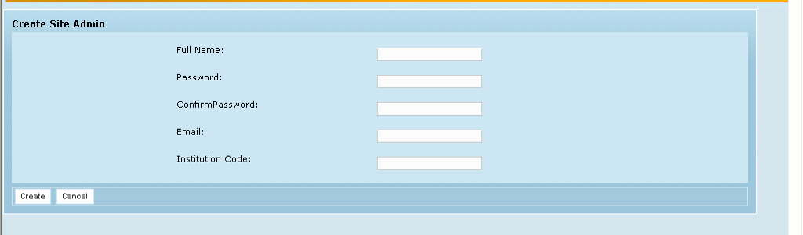

Field /Label | Input-Control | Data Type | Remarks / db Table>field
Create Site Admin
Full Name: | Textbox | varchar(255) | person>user_real_name
Password: | Textbox | varchar(255) | person> password
Confirm Password: | Textbox | varchar(255) | (Just for confirmation); Validation to check hat both entries are same
Email: | Textbox | varchar(255) | person> email
Institution Code: | Textbox | varchar(255) | party>code
Create | Button |  | On clicking, System will send activation link along with login ID and Password to the email address provided
Cancel | Button

Registration confirmation Page

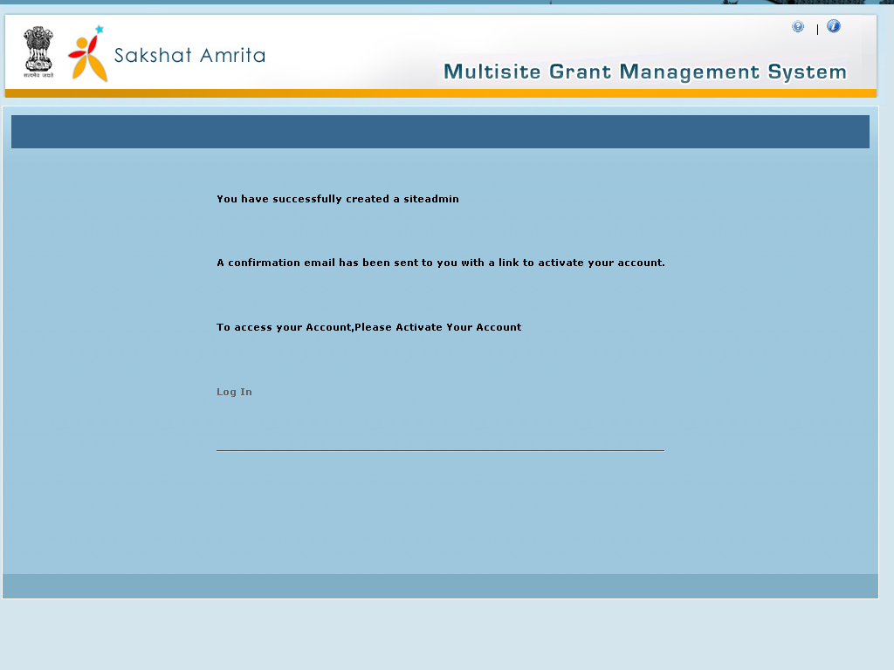

Activation confirmation page

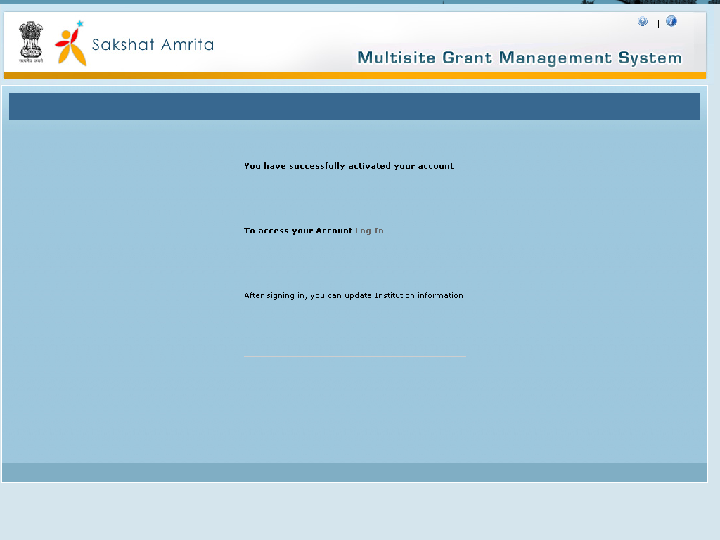
Click on Login

Click the login link to go to Log in

Associated tables

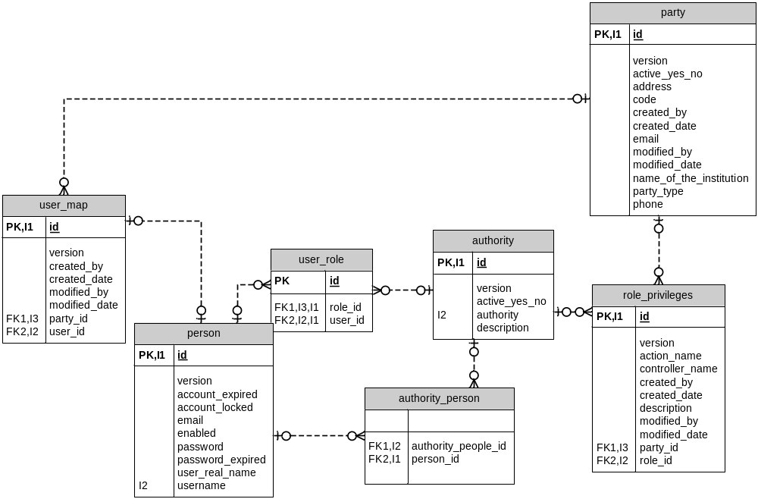

Data Dictionary

authority_person

Fields

Field | Type | Collation | Null | Key | Default | Extra | Privileges | Comment
authority_people_id | bigint(20) | (NULL) | YES | MUL | (NULL) |  | select,insert,update,references
person_id | bigint(20) | (NULL) | YES | MUL | (NULL) |  | select,insert,update,references

Indexes

Table | Non  unique | Key  name | Seq  in  index | Column  name | Collation | Cardinality | Sub  part | Packed | Null | Index  type | Comment
authority_person | 1 | FK4C086FD1C12321BA | 1 | person_id | A | 0 | (NULL) | (NULL) | YES | BTREE
authority_person | 1 | FK4C086FD1353431F2 | 1 | authority_people_id | A | 0 | (NULL) | (NULL) | YES | BTREE

Foreign Key Relationships

FK Id | Reference Table | Source Column | Target Column | Extra Info
FK4C086FD1353431F2 | authority | `authority_people_id` | `id` | ,
FK4C086FD1C12321BA | person | `person_id` | `id`
party

Fields

Field | Type | Collation | Null | Key | Default | Extra | Privileges | Comment
id | bigint(20) | (NULL) | NO | PRI | (NULL) | auto_increment | select,insert,update,references
version | bigint(20) | (NULL) | NO |  |  |  | select,insert,update,references
active_yes_no | char(1) | latin1_swedish_ci | NO |  |  |  | select,insert,update,references
address | varchar(255) | latin1_swedish_ci | NO |  |  |  | select,insert,update,references
code | varchar(255) | latin1_swedish_ci | NO |  |  |  | select,insert,update,references
created_by | varchar(255) | latin1_swedish_ci | NO |  |  |  | select,insert,update,references
created_date | datetime | (NULL) | YES |  | (NULL) |  | select,insert,update,references
email | varchar(255) | latin1_swedish_ci | NO |  |  |  | select,insert,update,references
modified_by | varchar(255) | latin1_swedish_ci | YES |  | (NULL) |  | select,insert,update,references
modified_date | datetime | (NULL) | YES |  | (NULL) |  | select,insert,update,references
name_of_the_institution | varchar(255) | latin1_swedish_ci | NO |  |  |  | select,insert,update,references
party_type | varchar(255) | latin1_swedish_ci | YES |  | (NULL) |  | select,insert,update,references
phone | varchar(255) | latin1_swedish_ci | NO |  |  |  | select,insert,update,references

Indexes

Table | Non  unique | Key  name | Seq  in  index | Column  name | Collation | Cardinality | Sub  part | Packed | Null | Index  type | Comment
party | 0 | PRIMARY | 1 | id | A | 66 | (NULL) | (NULL) |  | BTREE

person

Fields

Field | Type | Collation | Null | Key | Default | Extra | Privileges | Comment
id | bigint(20) | (NULL) | NO | PRI | (NULL) | auto_increment | select,insert,update,references
version | bigint(20) | (NULL) | NO |  |  |  | select,insert,update,references
account_expired | bit(1) | (NULL) | NO |  |  |  | select,insert,update,references
account_locked | bit(1) | (NULL) | NO |  |  |  | select,insert,update,references
email | varchar(255) | latin1_swedish_ci | NO |  |  |  | select,insert,update,references
enabled | bit(1) | (NULL) | NO |  |  |  | select,insert,update,references
password | varchar(255) | latin1_swedish_ci | NO |  |  |  | select,insert,update,references
password_expired | bit(1) | (NULL) | NO |  |  |  | select,insert,update,references
user_real_name | varchar(255) | latin1_swedish_ci | NO |  |  |  | select,insert,update,references
user_sur_name | varchar(255) | latin1_swedish_ci | YES |  | (NULL) |  | select,insert,update,references
username | varchar(255) | latin1_swedish_ci | NO | UNI |  |  | select,insert,update,references

Indexes

Table | Non  unique | Key  name | Seq  in  index | Column  name | Collation | Cardinality | Sub  part | Packed | Null | Index  type | Comment
person | 0 | PRIMARY | 1 | id | A | 314 | (NULL) | (NULL) |  | BTREE
person | 0 | username | 1 | username | A | 314 | (NULL) | (NULL) |  | BTREE
role_privileges

Fields

Field | Type | Collation | Null | Key | Default | Extra | Privileges | Comment
id | bigint(20) | (NULL) | NO | PRI | (NULL) | auto_increment | select,insert,update,references
version | bigint(20) | (NULL) | NO |  |  |  | select,insert,update,references
action_name | varchar(255) | latin1_swedish_ci | NO |  |  |  | select,insert,update,references
controller_name | varchar(255) | latin1_swedish_ci | NO |  |  |  | select,insert,update,references
created_by | varchar(255) | latin1_swedish_ci | YES |  | (NULL) |  | select,insert,update,references
created_date | datetime | (NULL) | YES |  | (NULL) |  | select,insert,update,references
description | varchar(255) | latin1_swedish_ci | YES |  | (NULL) |  | select,insert,update,references
modified_by | varchar(255) | latin1_swedish_ci | YES |  | (NULL) |  | select,insert,update,references
modified_date | datetime | (NULL) | YES |  | (NULL) |  | select,insert,update,references
party_id | bigint(20) | (NULL) | NO | MUL |  |  | select,insert,update,references
role_id | bigint(20) | (NULL) | NO | MUL |  |  | select,insert,update,references

Indexes

Table | Non  unique | Key  name | Seq  in  index | Column  name | Collation | Cardinality | Sub  part | Packed | Null | Index  type | Comment
role_privileges | 0 | PRIMARY | 1 | id | A | 506169 | (NULL) | (NULL) |  | BTREE
role_privileges | 1 | FK797EEF4B2177BCA7 | 1 | role_id | A | 18 | (NULL) | (NULL) |  | BTREE
role_privileges | 1 | FK797EEF4B4B78CFDA | 1 | party_id | A | 18 | (NULL) | (NULL) |  | BTREE

Foreign Key Relationships

FK Id | Reference Table | Source Column | Target Column | Extra Info
FK797EEF4B4B78CFDA | party | `party_id` | `id` | ,
FK797EEF4B2177BCA7 | authority | `role_id` | `id`
user_map

Fields

Field | Type | Collation | Null | Key | Default | Extra | Privileges | Comment
id | bigint(20) | (NULL) | NO | PRI | (NULL) | auto_increment | select,insert,update,references
version | bigint(20) | (NULL) | NO |  |  |  | select,insert,update,references
created_by | varchar(255) | latin1_swedish_ci | NO |  |  |  | select,insert,update,references
created_date | datetime | (NULL) | YES |  | (NULL) |  | select,insert,update,references
modified_by | varchar(255) | latin1_swedish_ci | NO |  |  |  | select,insert,update,references
modified_date | datetime | (NULL) | YES |  | (NULL) |  | select,insert,update,references
party_id | bigint(20) | (NULL) | NO | MUL |  |  | select,insert,update,references
user_id | bigint(20) | (NULL) | NO | MUL |  |  | select,insert,update,references

Indexes

Table | Non  unique | Key  name | Seq  in  index | Column  name | Collation | Cardinality | Sub  part | Packed | Null | Index  type | Comment
user_map | 0 | PRIMARY | 1 | id | A | 281 | (NULL) | (NULL) |  | BTREE
user_map | 1 | FKF022E2E885837584 | 1 | user_id | A | 281 | (NULL) | (NULL) |  | BTREE
user_map | 1 | FKF022E2E84B78CFDA | 1 | party_id | A | 70 | (NULL) | (NULL) |  | BTREE

Foreign Key Relationships

FK Id | Reference Table | Source Column | Target Column | Extra Info
FKF022E2E84B78CFDA | party | `party_id` | `id` | ,
FKF022E2E885837584 | person | `user_id` | `id`
user_role

Fields

Field | Type | Collation | Null | Key | Default | Extra | Privileges | Comment
role_id | bigint(20) | (NULL) | NO | PRI |  |  | select,insert,update,references
user_id | bigint(20) | (NULL) | NO | PRI |  |  | select,insert,update,references

Indexes

Table | Non  unique | Key  name | Seq  in  index | Column  name | Collation | Cardinality | Sub  part | Packed | Null | Index  type | Comment
user_role | 0 | PRIMARY | 1 | role_id | A | 52 | (NULL) | (NULL) |  | BTREE
user_role | 0 | PRIMARY | 2 | user_id | A | 263 | (NULL) | (NULL) |  | BTREE
user_role | 1 | FK143BF46A85837584 | 1 | user_id | A | 263 | (NULL) | (NULL) |  | BTREE
user_role | 1 | FK143BF46A2177BCA7 | 1 | role_id | A | 52 | (NULL) | (NULL) |  | BTREE

Foreign Key Relationships

FK Id | Reference Table | Source Column | Target Column | Extra Info
FK143BF46A2177BCA7 | authority | `role_id` | `id` | ,
FK143BF46A85837584 | person | `user_id` | `id`

